Would you be prepared for an unexpected result on a routine test? I wasn’t
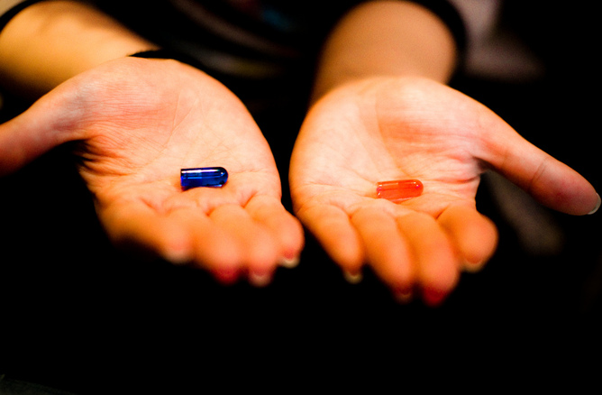The red pill or the blue pill? Kirainet, CC BY-NC-SA
Many people participate in biomedical research and it is estimated that one in 30 of us is enrolled in a cohort study at any one time. These studies contribute to, and enhance, our understanding of health and illness and include the UK Biobank, which has collected blood, urine and saliva samples from half a million people. The Biobank is now going further, with plans to image the brains, hearts, bones and blood vessels of thousands of participants and carry out DNA analysis.
While most research proposals are carefully crafted, these kinds of scientific enquiry may also yield unanticipated information. What should happen if, while looking at fMRI scans of participants’ brains, a researcher notices changes or markers unconnected to the study but which may indicate a health problem? Or what if when taking baseline measurements, a researcher discovers a participant appears to have elevated blood pressure or traces of protein in the urine sample?
I received unexpected news from an optician, who found what turned out to be the first signs of multiple sclerosis during a routine appointment. This has made me personally, as well as professionally, interested in the implications of so-called “incidental findings” – whether or not a participant, or in my case a patient, has consented to the possibility that it might happen. With so many of us signed up to studies and technology increasing the amount and detail of the information we collect, developed thinking and guidance about how to manage this is only beginning to emerge.

Not something we can dodge
Two of the principal funders of biomedical research, the Medical Research Council and the Wellcome Trust, recently issued joint guidance on feeding back health-related findings made during research. The publication is welcome, not least because it makes it clear that the issue is something we should be thinking about. While generalised advice is, quite properly, resisted, the guidance makes it clear that this is not an ethical issue researchers can dodge.
There is practical guidance too. Particular attention is paid to the process of seeking consent and how it relates to incidental findings. The factors that should inform how a research team approaches these kinds of findings are delineated: probability, severity, reliability and clinical utility are all cited as influential considerations in grappling with this moral dilemma. While such pragmatism and flexibility is commendable, the devil is, as ever, in the interpretive detail.
Returning to the example of the unexpected markers on the fMRI image, does the framework help decide what to do next? Brain imaging is problematic because it is an uncertain finding in a field where what is known and understood are limited. If we get over the significant assumption that there is agreement over the presence and meaning of changes on the brain image, who decides its clinical significance?
The other two examples of the raised blood pressure or traces of protein in the urine would be easier consider, withmeasurements that are considered demonstrably “abnormal” (though I use inverted commas here because “abnormal” itself is a contested concept). Even so, a cursory review of the history of hypertension reveals that what constitutes an acceptable blood pressure is a moveable target.
And in assessing clinical significance, a single recording of raised blood pressure or the trace of protein in one sample is of limited use in making a meaningful judgement about significance. The measurements themselves are the starting point for a clinical assessment and a shared interpretation that relates to both numerical and human values.

More than just an image
What matters is not a consensus view of the implications of this finding, but its meaning for the individual in whose body these changes exist. This is a moral decision not about a mere image of a brain scan, for example, but about a person – a human being with values, fears, beliefs and preferences that may be unknown, and unknowable, to the research team who made the observation on the scan.
It can be difficult for any of us to know how we will respond to an unanticipated health finding. And this difficulty is not overcome by giving us a fuller consent form and raising the possibility that something unwelcome may be found and relayed to us. As my experience went, as someone who considered myself thoughtful and self-aware, I could, and would, never have predicted that I would respond as I did; irrespective of how carefully my consent was sought.
When I attended the optician appointment I had consented to the possibility that eye examinations may yield medical information that may be insignificant, benign or cause for concern. Expecting to depart only with a new set of frames, I left the optician grappling with the idea that I might have multiple sclerosis. The woman who had consented to the possibility of receiving that information was woefully unprepared for the reality of receiving that information.
For this guidance to have meaning, there also needs to be a commitment to collaboration between different professionals and researchers, all working across different disciplines. The researcher with the focused question or hypothesis needs to know what to consider when they encounters incidental findings, but who to involve, when and how to share information. At each stage, someone has to take responsibility for making difficult interpretative judgements, decisions and communicating these to an individual or service that then has responsibility for sharing the finding – or not – with the person in whose body the health issue exists.
As I learned at the optician and in subsequent appointments with many doctors, the simplicity of the phrase “sharing the finding” belies the life-altering power of the task. It will be a considerable challenge, particularly in the complex organisational structure within which much research, particularly large-scale studies, takes place. And to give meaning to this framework, individuals and groups will have to engage in the critical interrogation of knowledge and information, an analysis of benefits and harms and do so in the context of ever-present uncertainty. It is quite an ethical ask.

